https://www.loudountimes.com/news/loudoun-superintendent-discusses-possible-contingency-plans-for-nextschool-year/article_4d013af4-8499-11ea-ab90-df3c96b36225.html
FEATURED
Loudoun superintendent discusses possible contingency plans for next school year
By John Battiston, jbattiston@loudountimes.com
Apr 22, 2020
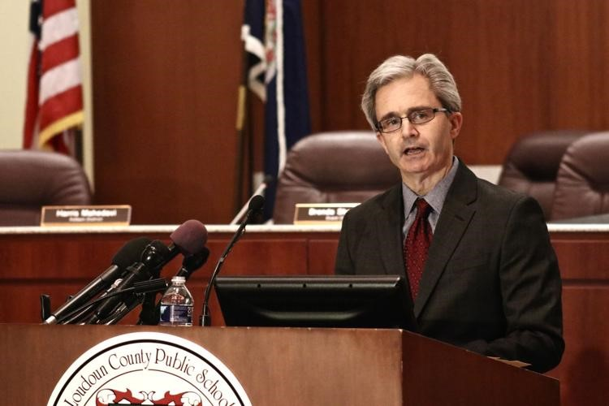
Loudoun County Public Schools Superintendent Eric Williams speaks to the press in early March after announcing school would be cancelled through March 20 due to coronavirus concerns.
Times-Mirror/John Battiston
Loudoun County Public Schools Superintendent Eric Williams presented a list of potential scenarios for the 2020-2021 school year to the Loudoun County School Board during its emergency meeting Tuesday to address the COVID-19 crisis.
Williams began by discussing various models forecasting the rate of coronavirus spread and peak hospitalizations, which Virginia State Epidemiologist Lilian Peake presented to commonwealth superintendents last week.
Models from the Institute for Health Metrics and Evaluation show hospitalizations peaking between late April and late May, while a model produced by the University of Virginia projects this peak for mid-July to late August, assuming Gov. Ralph Northam's (D) stay-at-home order lifts as planned on June 10.
The superintendent then summarized three basic scenarios for the return to school next year: Scenario 1 would send students back to school buildings without major physical distancing or public health mitigation strategies; Scenario 2 would involve a physical return to school with such strategies implemented; and Scenario 3 would extend distance learning, either right from the start of classes or after a period of in-person teaching and learning.
"We're using these three basic scenarios to inform our planning, but I want to emphasize that the planning will be modular," Williams said. "We will take modules or parts of planning for one scenario and integrate them with modules of planning for other scenarios in order to respond to hybrid scenarios."
Williams said he hopes planning for these scenarios will provide "directional clarity" and that they will help LCPS families and staff enhance their understanding of possible pathways moving forward. When planning for the various scenarios, he said the division will aim to articulate its purpose for each one, as well as what success would look like in each case.
"That will include identifying examples of actions that need to be taken in order to prepare for each scenario, and questions that need to be answered," he said.
LCPS will initially build prototype responses to the scenarios, or "roadmaps," rather than detailed, step-by-step manuals. Each prototype will then be refined over time with help and feedback from various stakeholders including employees, parents, students, advisory groups, the School Board and other community members.
Per Williams, this strategy allows the division to "support continual progress without unrealistically developing a highly detailed plan in the absence of clear information," before shifting to more detailed planning in the future.
Several board members had questions for Williams later in the meeting, including Harris Mahedavi
(Ashburn District), who asked whether LCPS will consider the role funds play in different scenarios. Williams responded yes, saying the division has a certain level of flexibility for changed expenditures within the budget and that board action will dictate major adjustments.
Jeff Morse (Dulles District) asked whether a date has been determined for when LCPS will decide which scenario to pursue, a question Williams said staff will return to as plans are refined in the coming weeks and months. Morse then suggested that the board forgo its usual July hiatus this year to assist in necessary decision-making before school presumably begins in late August.
"I do apologize if we end up holding meetings in July, because I know that will impact staff as much as it impacts the board, but I think we're in unprecedented times, and ... we need to have as solid a plan as humanly possible when we expect our teachers to come back in the fall," Morse said.
Tuesday's meeting, which was conducted virtually via Cisco WebEx, is available to view in full at vimeo.com/410160962.

John Battiston

