Apr 21, 2020,12:28pm EDT
3 Coronavirus Facts Americans Must Know Before Returning To Work, School
Robert Pearl, M.D.Contributor
Healthcare
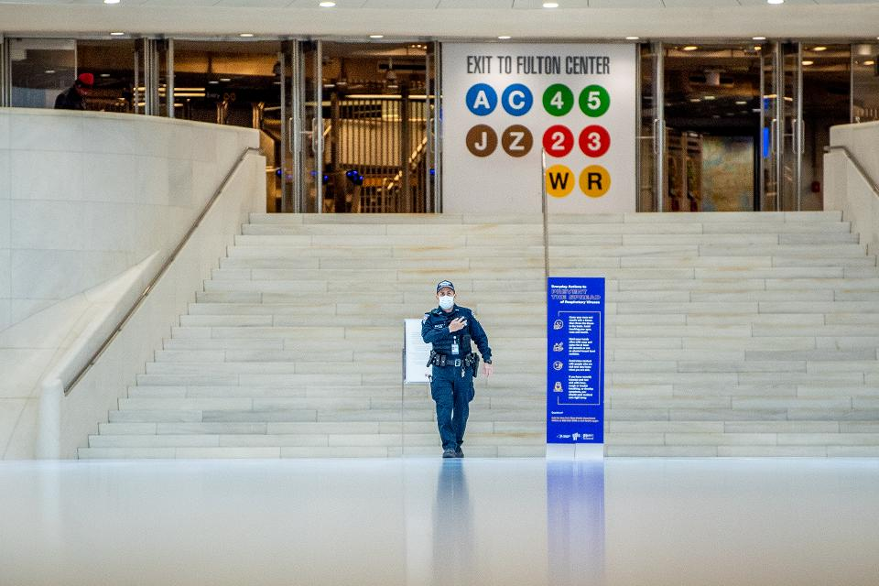
GETTY IMAGES
We can’t un-bungle our nation’s COVID-19 response. Political leaders acted too slowly, health agencies committed unforced errors with testing kits and, amid the confusion, an information fog settled over the land.
Americans remain afraid, perplexed and chronically misinformed (despite wall-to-wall coronavirus coverage across the leading cable-news programs and print publications).
To counter the uncertainty, any plan to get us out of the coronavirus crisis must first acknowledge and broadly communicate three immutable, scientific facts.
Fact 1: Staying home saves lives but it doesn’t kill the virus
Weeks of social distancing and self-isolation in the United States have made us all safer. These precautions slowed the spread of COVID-19, thus helping to “flatten the curve.” Doing so buys hospitals and critical care centers enough time to staff up and stock diagnostic tests, protective gear and ventilators.
However, it’s imperative that Americans understand these measures do not eliminate the virus. By staying home (and six feet apart from each other), we did not (and cannot) outlast our opponent.
PROMOTED
Whenever we return to our jobs, schools and community gatherings—be it this spring, summer or fall—infections will rise. It’s not a prediction. It’s a biological fact.
To avoid overwhelming critical care services, local reopening strategies must keep a multitude of safety precautions in place, especially those meant to protect the most vulnerable populations. The elderly—and those with chronic illnesses like heart and lung disease—remain at highest risk and therefore must continue to shelter in place. As such, local governments should provide them with food, housing and safe transport as needed.
Fact 2: We’re in this for the long-haul
There’s a bitter paradox brewing in the United States. The spread of COVID-19 has been, and still is, largely predictable based on objective and publicly available data. Yet most people—including Wall Street investors, governors and sports-starved fans—seem unable to comprehend the mathematical realities of a virus that spreads exponentially.
As federal and state officials hammer out plans to reopen the economy, our nation must accept the unfortunate truth that every path forward is booby-trapped.
The coronavirus will persist until there is either (a) a safe vaccine (still 12 to 18 months away) or (b) until there is “herd immunity,” whereby two-thirds of the nation (about 200 million people) must become infected, recover and develop the appropriate antibodies. This, too, will take at least a year.
A theoretical third option, which involves aggressively testing and quarantining all infected individuals, no longer applies. In the United States, that ship sailed back in February when the number of cases soared into the tens of thousands with no way of tracking carriers and their recent contacts. At this point, too many people are infected and too many of the infected show no symptoms, making it impossible to rid the virus through containment.
So, what options do we have? Trump recently announced he is “authorizing each individual governor of each individual state to implement a reopening, and a very powerful reopening, plan of their state.”
This is a dangerous tightrope to walk at the state level. Governors must ensure they don’t ease restrictions too quickly or too slowly.
Reports of increased mental health crises, domestic violence incidents and suicides demonstrate the urgency of getting people out of their houses and back to their normal lives. At the same time, the Spanish Flu of 1918 reminds us that the “second wave” of a virus can prove just as deadly as the first.
Medical requirements for reopening the country must therefore include:
- Limiting exposure, likely for a year. Restaurants and shops should reopen only under three conditions: (1) community hospitals have additional capacity to handle an uptick in demand, (2) all local businesses agree to restrict indoor capacity based on the six-foot rule, and (3) all staff wear masks.
- Making tests free and convenient. Testing for COVID-19 requires the insertion a 6-inch long swab into the back of the nasal passage through one nostril and rotating the swab several times for 15 seconds. It’s a painful process, which is why Americans won’t consent to a reopening strategy that involves daily tests. Nevertheless, local governments need to make testing available at no cost to anyone with COVID-19 symptoms. Those who are confirmed should immediately self-quarantine.
- Helping health officials. In parallel to molecular testing for the disease, our nation must ramp up serological testing, which can identify those that were infected, have since recovered and developed antibodies—thus telling health officials how close we are to herd immunity.
Fact 3: Our nation is ignoring the most important metric
Every day, cable-news chyrons display the latest numbers of confirmed COVID-19 cases and deaths. These figures are eye-popping, but they tell us very little about the relative safety of reopening the country.
That’s why it’s important for all Americans to acquaint themselves with a different, more-informative metric.
R₀ (pronounced “R naught”) is a number that indicates the contagiousness of an infectious disease like COVID-19. Specifically, it tells us the average number of unvaccinated (or otherwise vulnerable) people who will contract a disease from one contagious individual.
For example, measles has an R₀ of 12 to 18, which means that one infected person will transmit the virus to as many as 18 unprotected people. The R₀ for HIV is 4.0 and the seasonal flu is 1.2.
Early data suggests the R₀ of COVID-19 is between 2.5 and 3.0. However, the actual number depends not only on the biology of the disease but on the actions people take.
For example, when people observe social distancing and adhere to rigid shelter-in-place measures, the number drops. In the UK, where strict lockdown protocols and frequent testing are in place, the R₀ is low (currently estimated to be 0.62). Conversely, the R₀ value grows much higher in densely packed conditions including sports arenas, large conferences and events like Mardi Gras.
As explained here, the R₀ value shows the potential transmissibility of the disease, and its careful monitoring constitutes both the safest and fastest way for the United States to implement a reopening strategy:
- If R₀ is less than 1.0, each infected person transmits the virus to less than one other individual. As a result, the disease incidence will decline and the virus will slowly die out.
- If R₀ equals 1.0, each infected person will transmit the virus to one other individual. As a result, the infection rate will remain constant (though the curve will be flat) and there won’t be a future spike (or second wave).
- If R₀ is more than 1.0, each infected person will pass the virus onto more than one individual. As such, the number of infected people will rise and the number of individuals needing critical care can quickly surge.
If we want Americans to better understand the relative safety and preparedness of local and regional “reopening” plans, we must base our decisions on this important number.
Facts Save Lives
About 90% of the country has been on some form of lockdown order for several weeks now. People are losing patience. As our nation eagerly eyes the future, we must let science inform our decisions about reopening small businesses, allowing students to return to class and easing social restrictions.
If we move ahead too quickly, we risk losing lives unnecessarily. If we move too slowly, we also risk unnecessary deaths. We can’t allow politics or panic to push our nation too far in either direction. These three facts, based on science, should guide the way.
Follow me on Twitter or LinkedIn. Check out my website or some of my other work here.
Robert Pearl, M.D.

